Standard Operating Procedure for the management of COVID-19 symptoms for education and childcare settings for academic year 2021/22

(nurseries, childminders, schools and colleges)
Document Control

Version Control
Version | Version Date | Author | Reasons for Change
1 | 24.8.2021 | AH/RD | - Merger of all educational/childcare settings SOPs into one document  - Change in government guidance regarding contact tracing and self-isolation  - Introduction of new infectious disease notification and management system for education/childcare settings
2 | 20.10.2021 | AH/RD | - Updated COVID-19 Reporting Procedures - points to consider when reporting cases on the new system  - Updated contact tracing – additional information on contact tracing for staff members  - Updated outbreak management procedures - including a new checklist, letters and testing requirements
3 | 23.11.2021 | AH/RD | - Updated ‘close contacts’ large outbreak parent letter
4 | 25.11.2021 | AH/RD | - Removal of requirement to stay off setting pending PCR result for ‘close contacts’ (household and setting)  - Update to parent large outbreak letters  - Update to Outbreak Management Checklist with removal of requirement to isolate pending PCR result for close contacts
5 | 13.12.2021 | Rebecca Downing | - Changed the embedded CYP email to the HPT Schools email
6 | 28.12.2021 | Sally Cornfield | - Updated to reflect new operating procedures in Public Health from January 2022

Authorship
Name | Department | Contact Details
Rachael Doyle | Public Health | rachael.doyle@dudley.gov.uk
Anna Hill | Public Health | anna.hill@dudley.gov.uk
Rebecca Downing | Public Health –COVID Response | rebecca.downing@dudley.gov.uk
Sally Cornfield | Public Health | sally.cornfield@dudley.gov.uk

Contents
Section | Description | Page Number
 | Introduction | 3
 | Key Contact Details | 4
 | COVID-19 Reporting Procedures | 5
 | Symptoms of COVID-19 | 6
 | Positive COVID-19 Case - Management for Educational Settings | 9
 | Outbreak Management Plan | 10
 | Managing CYP attendance when a member of their household is positive | 10
8. | Notifying parents/carers of a positive case and/or outbreak within a setting | 11
9. | When to self isolate FOLLOWING A POSITIVE PCR test | 11
10. | Asymptomatic Testing | 13
Appendix A | COVID-19 Outbreak Management Plan | 14
Appendix B | COVID-19 Outbreak Management Checklist for Additional Measures | 20
Appendix C | Threshold Guidance & Template Letters | 24

Review
This Standard Operating Procedure will be reviewed monthly, or more frequently if new guidance became available, or upon request by a stakeholder involved in the effective operation of this SOP.

- Introduction
This Standard Operating Procedure (SOP) has been approved by Dudley Council’s Test, Trace and Isolate sub-group for Educational Settings. It outlines the procedures to be followed:
- If a child or young person (CYP) or staff member displays symptoms of coronavirus, either at home or at their setting*
- When a test result is received (both PCR and LFT)
- In the event of an outbreak of COVID-19

*Throughout this document ‘settings’ are referred to – this relates to educational and childcare settings, including early years settings, schools, and FE providers.
This SOP should be read in conjunction with your setting’s risk assessment and the following applicable guidance. Early years settings should also refer to local guidance provided by Dudley Council’s Early Years team.
Schools: https://assets.publishing.service.gov.uk/government/uploads/system/uploads/attachment_data/file/1044530/Schools_guidance_Jan_22.pdf
FE colleges and providers: https://assets.publishing.service.gov.uk/government/uploads/system/uploads/attachment_data/file/1044534/Further_education_COVID-19_operational_guidance.pdf
Early years (nurseries): https://assets.publishing.service.gov.uk/government/uploads/system/uploads/attachment_data/file/1040671/Actions_for_early_years_and_childcare_providers_during_the_COVID-19_pandemic.pdf
Special schools: https://assets.publishing.service.gov.uk/government/uploads/system/uploads/attachment_data/file/1044535/SEND_guidance_FC_update.pdf
Early Years and Primary Google Document Sharing Platform https://drive.google.com/drive/folders/1X4fLxy6_ppmpmKrv3hT2M6cduAN_GS54
Further Education and Secondary Google Document Sharing Platform https://drive.google.com/drive/folders/1jYv0MjFyIIbzgPn_1S10OuRgfrj_b5_P
Please regularly refer to the following guidance to stay up to date with any changes:
- National guidance: https://www.gov.uk/coronavirus/education-and-childcare
- Local guidance: Log onto www.revolutionforschools.dudley.gov.uk, click on resources, scroll down, click on the COVID-19 Information page
- Document warehouse on the Infectious Disease Notification and Management System via School Life Platform (See section 1)

Key contact details
Team | Contact Details | When to contact
Department for Education (DfE) for all settings. | 0800 046 8687  The line will be open Monday to Friday from 8.00am to 6.00pm, and 10.00am to 4.00pm on Saturdays and Sundays. | Helpline - available for advice on the action to take in response to a positive case. Contacting the helpline is optional and positive cases do not need to be reported to DfE via this line.  Online attendance form daily return Click on this link to complete this survey (only applicable for schools). DfE is asking schools to continue to submit their attendance data daily throughout September 2021. From 1 October 2021, submission of returns will move from daily to weekly.
Dudley Council Public Health | HPT.School@dudley.gov.uk  Monitored Monday to Friday from 9:00am to 4:00pm.  If your enquiry is urgent on a weekend or a Bank holiday, please contact covid19@dudley.gov.uk or 01384 81 4444. | All positive cases to be reported to Dudley Public Health via Infectious Disease Notification and Management System (see section 1)  At this time Dudley Health Protection Team (HPT) will only support settings in the event of outbreak across multiple class groups and years when notified via the Infectious Disease Notification and Management System which will be monitored by the Team.  Public Health COVID-19 questions, questions about this SOP and/or any concerns about high reported absence which is suspected to be COVID-19 related.
School Nurse  Service for schools | 01384 408990 | For advice and support if there is concern that a test has not been arranged, applicable for schools only.
Ofsted for early years | Use your usual notification channels | Report all positive cases and if the setting is advised to close as a result of a positive case.

3. COVID-19 Reporting Procedures
We request that all positive COVID-19 cases (PCR and LFT) within any education and childcare setting are reported to Dudley Council Public Health via the Infectious Disease Notification and Management System (via a secure login to the School Life admin area https://admin.sch.life) to enable Dudley Public Health to monitor the number of positive cases in all settings.
If you have not received your setting’s log-in details, please send the following to HPT.School@dudley.gov.uk.
Setting name | First name | Surname | Role in the setting | Email address
User guidance can be found in the FAQ that accompany this SOP.
Points to consider when reporting positive cases include:
- Positive cases - only report positive results (PCR or LFT) on the system.
- Reporting days - please report as soon as you become aware, this will allow the HPT to monitor any areas of concern.
- Class/group names - ensure that all cases are assigned to a class/group to ensure accurate data analysis and outbreak management
- Symptom onset – if you have ticked that the case has symptoms, ensure you add a symptom onset date, otherwise the isolation dates will not calculate. If the case does not have symptoms select ‘asymptomatic’ on the symptom’s dropdown.
- Likely Infection Source - If there are already cases within the class /subject of the positive case you are reporting, please tick ‘setting’ as the likely infection source. If the infection source is unknown, tick ‘unknown’. If parents think/assume that their child got the infection at their education/childcare setting, only tick ‘setting’ if you can confirm a link with a positive case at the setting e.g. via a shared lesson.
- Notes section on reporting form - use the note section to provide us with as much information about the positive case as possible e.g. if the infection source is from the household, provide details about who in the household is positive and if you provide details of any positive siblings indicate which setting they attend if known. For secondary schools please include details of other cases that the positive case you are reporting has mixed with e.g. shared lessons.
Notes section on the Dashboard - use the notes section on the Dashboard to provide details of any actions/measures you have taken above and beyond National Guidance e.g., parent notification letters sent out, restriction of mixing, face coverings, completed outbreak management checklist. Attachments can be added to this section as well.

Please note: the Infectious Disease Notification and Management System will continue to automatically calculate 10 days isolation period regardless of the new guidance.

Please note: Dudley HPT will support settings when they breach 10% across multiple class and year groups - they will get this information from the Infectious Disease Notification and Management System

- Symptoms of COVID-19
The Council website is regularly updated to reflect government advice here https://www.dudley.gov.uk/council-community/emergencies/covid-19-advice/government-advice/
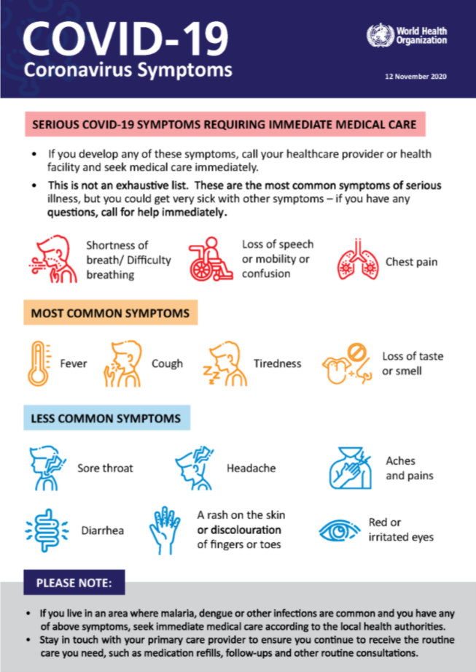
The most recent WHO poster (NOV 2020) is below. Updates can be accessed here https://www.who.int/emergencies/diseases/novel-coronavirus-2019/advice-for-public

- If you have COVID-19 symptoms you should stay at home and self-isolate immediately. You should arrange to have a PCR test as soon as possible. If this PCR test result is positive, you must continue to self-isolate.
- If you do not have COVID-19 symptoms, but you have a positive PCR test result, you must stay at home and self-isolate
It is important to note that:

- From 14 December 2021 adults who are fully vaccinated and all children and young people aged between 5 and 18 years and 6 months identified as a contact of someone with COVID-19 are strongly advised to take a LFD test every day for 7 days and continue to attend their setting as normal, unless they have a positive test result.
- Daily testing of close contacts applies to all contacts who are:
- fully vaccinated adults – people who have had 2 doses of an approved vaccine
- all children and young people aged 5 to 18 years and 6 months, regardless of their vaccination status
- people who are not able to get vaccinated for medical reasons
- people taking part, or have taken part, in an approved clinical trial for a COVID-19 vaccine Children under 5 years are exempt from self-isolation and do not need to take part in daily testing of close contacts
- From Wednesday 22nd December 2021 isolation periods for positive COVID-19 cases change in England. People can stop isolating (regardless of vaccination status) if they:
- Take two lateral flow tests on subsequent days, at least a full 24 hours apart, with the first test on day 6 of their isolation period, followed by day 7.
- Have negative results on both these days and do not have a high temperature.

- From Tuesday 4th January 2022 where pupils in year 7 (which would be children who were aged 11 on 31 August 2021) and above are educated*, face coverings are temporarily required (until 26 January 2022 when the National guidance will be reviewed)
- Face coverings should be worn in classrooms. This does not apply in situations where wearing a face covering would impact on the ability to take part in exercise or strenuous activity, for example in PE lessons.
- Pupils in these settings must also wear a face covering when travelling on public transport and should wear it on dedicated transport to and from school.
- Teachers are not ordinarily expected to wear a face covering in the classroom if they are at the front of the class, to support education delivery, although settings should be sensitive to the needs of individual teachers.

- In primary schools*, it is recommended that face coverings should be worn by staff and adults (including visitors) when moving around in corridors and communal areas.
- Health advice continues to be that children in primary schools should not be asked to wear face coverings. National guidance includes “Circumstances where people are not able to wear face coverings” for exceptions to this.
- Face coverings do not need to be worn when outdoors.
*Schools, as employers, have a duty to comply with the Equality Act 2010 which includes making reasonable adjustments for disabled staff. They also have a duty to make reasonable adjustments for disabled pupils, to support them to access education successfully. No pupil should be denied education on the grounds that they are not wearing a face covering
- Testing for the less common symptoms remains voluntary and settings cannot require individuals with these symptoms to get a test. Individuals with any of these other symptoms (apart from diarrhoea and vomiting) can carry on attending their setting if they are well enough to do so.

- Individuals should not do another PCR test within 90 days of your positive result. This is because it is possible for tests to remain positive for some time after infection. However, they must self-isolate and seek a new test if they have any new symptoms of COVID-19 or get a positive LFT result.

The national testing centres across the borough have good availability and tests can be booked through the NHS website or NHS Test & Trace App. Individuals booking a test due to wider symptoms will need to select ‘’My local council or health protection team has asked me to get a test, even though I do not have symptoms”. You can also order LFT tests here https://www.gov.uk/order-coronavirus-rapid-lateral-flow-tests

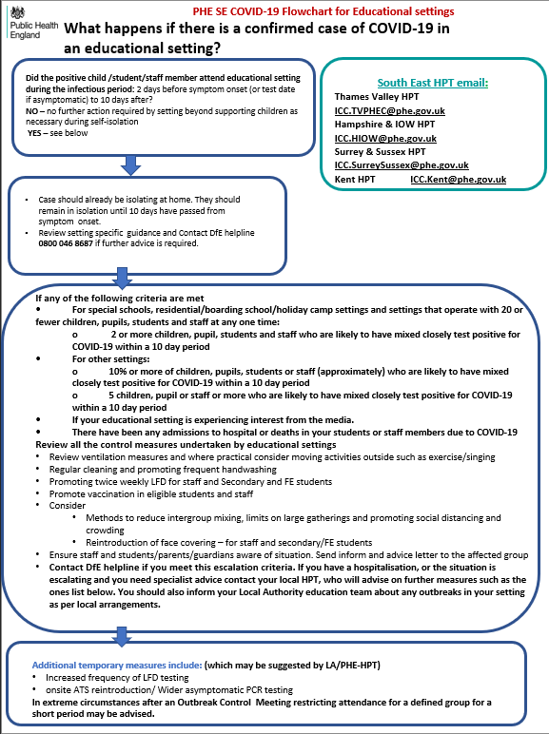
- Positive COVID-19 Case - Management for Educational & Child Care Settings
Useful Contact Details:
HPT.School@dudley.gov.uk
DFE Helpline 0800 046 8687

Cases should already be isolating at home. They should remain in isolation until 10 days have passed from symptom onset or from 7 days with 2 negative LFT tests.

Complete the Dudley Outbreak Checklist and Contact DfE helpline 0800 046 8687 if further advice is required
- Outbreak Management Plan
All education and childcare settings should have contingency plans (or outbreak management plans) describing how they would operate if they were advised to reintroduce any measures. A template is for all settings is in Appendix A and national guidance here https://www.gov.uk/government/publications/coronavirus-covid-19-local-restrictions-in-education-and-childcare-settings/contingency-framework-education-and-childcare-settings
Settings are asked to report all positive cases within their setting to Dudley Council (via a secure login to the School Life admin area https://admin.sch.life) It is important that settings report all cases, to enable Dudley Council Public Health to monitor the number of cases in each setting and provide appropriate advice, on a case by case basis, taking into account the current situation and local epidemiology.

You should clean and disinfect rooms/areas the suspected case was using – please follow COVID-19: cleaning of non-healthcare settings outside the home and ensure appropriate PPE (minimum gloves and apron). https://www.gov.uk/government/publications/covid-19-decontamination-in-non-healthcare-settings/covid-19-decontamination-in-non-healthcare-settings

If you think you have an outbreak and feel you need support, contact the DfE helpline in the first instance, if the situation is escalating or you have concerns complete the checklist in Appendix B for additional measures below.
If you need specialist advice contact your local HPT HPT.School@dudley.gov.uk

- Managing CYP attendance when a member of their household is positive
Anyone who lives in the same household as a person who has symptoms of coronavirus (COVID- 19) or who has received a positive test result should follow the Stay at home: guidance for households with possible or confirmed COVID-19
Anyone aged under 18 years and 6 months is not legally required to self-isolate. However, they are strongly advised to take an LFD test every day for 7 days, and to self-isolate if any of these test results is positive

Children under 5 years are exempt from self-isolation and do not need to take part in daily testing of close contacts
Where possible make provision to ensure that family members (e.g., parents and siblings) that have tested positive do not leave the house to drop off other children to school or nursery.

- Notifying parents/carers of a positive case and/or outbreak within a setting

Settings should consider whether individuals in their setting (taking account of factors such as known vulnerability) need to be informed of a positive case. When informing individuals of a positive case, the setting should not disclose any information that could result in an individual being identified. Settings may make their own decisions on how they wish to communicate the information. The table in Appendix C provides a guide to the recommended thresholds to follow for each setting-type and the relevant letters to send out.

9. When to self isolate FOLLOWING A POSITIVE PCR test
Guidance is here https://www.nhs.uk/conditions/coronavirus-covid-19/self-isolation-and-treatment/when-to-self-isolate-and-what-to-do/ and summarised below:

You can return to your normal routine and stop self-isolating after 10 full days if your symptoms have gone, or if the only symptoms you have are a cough or anosmia, which can last for several weeks. If you still have a high temperature after 10 days or are otherwise unwell, stay at home and seek medical advice.
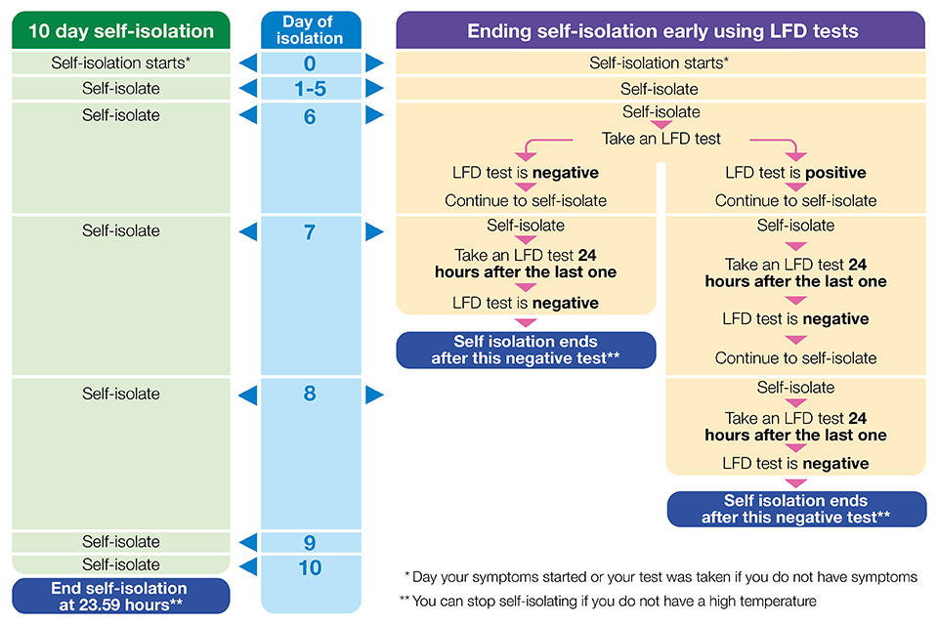
You may be able to end your self-isolation period before the end of the 10 full days. You can take an LFT test from 6 days after the day your symptoms started (or the day your test was taken if you did not have symptoms), and another LFT test on the following day. The second LFT test should be taken at least 24 hours later. If both these test results are negative, and you do not have a high temperature, you may end your self-isolation after the second negative test result.

Report your LFT test results after taking each test
If both of your LFT test results are negative, it is likely that you were not infectious at the time the tests were taken. To further reduce the chance of passing COVID-19 on to others, if you end your self-isolation period before 10 full days you are strongly advised:
- to limit close contact with other people outside your household, especially in crowded, enclosed or poorly ventilated spaces
- to work from home if you are able to
- in addition to venues where it is a legal requirement, wear a face covering in crowded, enclosed or poorly ventilated spaces and when you are in close contact with other people
- to limit contact with anyone who is at higher risk of severe illness if infected with COVID-19
- to follow the guidance on how to stay safe and help prevent the spread

If you are isolating because of a positive test result but did not have any symptoms, and you develop COVID-19 symptoms within your isolation period, start a new isolation period from the day your symptoms start.
If you develop COVID-19 symptoms at any point after ending your first period of isolation you and your household should follow the steps in this guidance again.
Most people with COVID-19 will experience a mild illness. Seek prompt medical attention if your illness or the illness of someone in your household is worsening.
As part of the dynamic risk assessment held by the setting it must cover the risks to the health and safety of employees and of persons (including pupils) who are not employees of the setting. www.gov.uk/government/publications/health-and-safety-advice-for-schools/responsibilities-and-duties-for-schools
Additionally: They must identify any group of employees identified by it as being especially at risk.
https://www.gov.uk/government/publications/actions-for-schools-during-the-coronavirus-outbreak/schools-covid-19-operational-guidance
If a setting identifies a member of staff as a close contact of a positive case at the setting and they are required to isolate (e.g. they are not fully vaccinated), leaders can arrange for the staff contact(s) to be added to the Test and Trace national system, so they receive a formal notification to isolate.
Taking this approach will also ensure that any agency staff or lower paid staff who need to isolate will be able to claim the self-isolation payment if they are eligible, as they have official notification of their requirement to isolate.

- Asymptomatic Testing
COVID-19 infection rates are very high and the Omicron variant is spreading rapidly. It is important that we all take steps to reduce the spread of COVID-19 infection in the community to save lives and protect the NHS.
- Testing remains important in reducing the risk of transmission of infection within schools. Staff and secondary school pupils should continue to test twice weekly at home, with lateral flow device (LFT) test kits, 3-4 days apart. Testing remains voluntary but is strongly encouraged.
- Secondary schools should also retain a small asymptomatic testing site (ATS) on-site until further notice so they can offer testing to pupils who are unable to test themselves at home.
- Schools are strongly encouraged to ask parents and other visitors to take a lateral flow device (LFT) test before entering the school.
- There is no need for primary age pupils (those in year 6 and below) to regularly test, unless they have been identified as a contact for someone who has tested positive for COVID-19 and therefore advised to take lateral flow tests every day for 7 days.
- Children under 5 years are exempt from self-isolation and do not need to take part in daily testing of close contacts

Appendix A

Delete and
replace with setting logo
COVID-19
Outbreak Management Plan
for
[Insert setting name]

Approved by: | [Name] | Date: [Date]
Last reviewed on: | [Date]
Next review due by: | [Date]

1. Introduction
This Outbreak Management Plan is based on the contingency framework for managing local outbreaks of COVID-19, provided by the Department for Education (DfE) and adapted from the template provided by The Key Support Services Ltd and will be used alongside the latest Government Guidance. The DfE’s COVID Contingency Framework states that settings should have an outbreak management plan, which describes how they would operate if there was an outbreak in school and when it may be necessary to implement additional measures to help manage a COVID-19 outbreak within the setting.
The purpose of this plan is to prepare for moving forwards with the government agenda. It is a national priority for education and childcare settings to continue to operate as normal during the COVID-19 pandemic.
The measures contained in this plan state the actions we will consider to be implemented in response to the following situations arising and with support and recommendations provided by the local authority (LA), Director of Public Health (DPH), Public Health England (PHE), health protection team or the national government.
It is the role of the [insert name(s) or role(s)] to oversee the coordination of this plan.

Thresholds

(bullet points 1 and 2 are applicable to the type of setting delete as appropriate)

- For most education and childcare settings, whichever of these thresholds is reached first:
• 5 children, pupils, students or staff, who are likely to have mixed closely*, test positive for COVID-19 within a 10-day period; or
• 10% of children, pupils, students or staff who are likely to have mixed closely* test positive for COVID-19 within a 10-day period

- For special schools, residential settings, and settings that operate with 20 or fewer children, pupils, students and staff at any one time: • 2 children, pupils, students and staff, who are likely to have mixed closely, test positive for COVID-19 within a 10-day period

- Evidence of severe of illness e.g. students or staff members admitted to hospital or a death as a result of a COVID–19 infection

- In response to a new Variant of Concern (VoC)

- Extremely high prevalence of COVID-19 in the local community / area

Mixing

*It is recognised that Identifying a group that is likely to have mixed closely will be different for each setting, but a group will rarely mean a whole setting or year group. We will identify groups using the following: (Delete the ones which aren’t applicable to your setting)
For early years, this could include:
• a nursery class
• a friendship group who often play together
• staff and children taking part in the same activity session together

For schools, this could include:
• a form group or subject class
• a friendship group mixing at breaktimes
• a sports team
• a group in an after-school activity

For boarding schools, this could include:
• staff and children taking part in the same class or activity session together
• children who share the same common space in a boarding house
• children who have slept in the same room or dormitory together

1:1 Actions to consider:
When the thresholds outlined above are reached we will review and reinforce the testing, hygiene and ventilation measures we already have in place. Further detail on these can be found in the guidance for each sector located at cleaning of non-healthcare settings

Dudley Council Public Health will work closely with our setting and provide us with advice and support on a case by case basis, taking into account the local situation. For example; if local rates are extremely high, a response is required to a ‘variant of concern’ (VOC) and other measures have failed to reduce transmission, then the thresholds for extra action may be higher than set out above.

Where action is necessary to help reduce transmission within our setting, these are the measures which may need to be temporarily introduced include:

- Additional/increased testing. The reintroduction of on-site testing may be advised by our local director of public health for individual settings or small clusters, or in settings across areas where an “enhanced response package” has been deemed appropriate
- Face coverings for staff (who are not exempt) when arriving at setting and moving around indoors in places where social distancing is difficult to maintain, such as in communal areas
- Face coverings for students (delete if primary or early years setting)
- Reintroducing students/children into bubbles and/or consistent groups
- Short term attendance restrictions, such as sending home a class or year group – this would only be advised in extreme cases, and as a last resort where all other risk mitigations have not broken chains of transmission within the setting
- Shielding for vulnerable individuals (shielding can only be introduced by national government)
- If an outbreak occurs, we will work with Dudley health protection team to help identify individuals who may have been in contact with known infectious individuals

2. Shielding
We will adhere to national guidance on the reintroduction of shielding, which would apply to those on the shielded patient list (SPL).
We will speak to individuals required to shield to risk assess the need for any additional protective measures in school or arrangements for home working or learning.

3. Other measures
If recommended, we will limit:
- Residential educational visits (delete if not applicable to your setting)
- Open days
- Transition or taster days
- Parents coming into setting
- Live performances

Add here any measures specific to your setting not previously covered. e.g. transport arrangements and comms

4. Attendance restrictions
Attendance restrictions will only be recommended as a last resort. If recommended, we will implement the measures in this section.
4.1 Eligibility to remain in setting
In the first instance, we will stay open for:
- Vulnerable pupils
- Children of critical workers
- Reception, Year 1 and Year 2 pupils
If further restrictions are recommended, we will stay open only for:
- Vulnerable pupils
- Children of critical workers
4.2 Education and support for pupils at home
For pupils required to stay at home, we will provide remote education that meets the same quality and quantity of education that pupils would receive in the setting, as outlined in our [insert location of your remote learning plan(s), e.g. remote learning policy including whether devices are distributed].
Delete if not applicable
The school will continue to provide lunch parcels for pupils eligible for benefits-related free school meals while they are not attending school because of COVID-19 isolation guidelines.
[Insert details of how you’ll distribute meals or lunch parcels to pupils (e.g. parents collect from school).]
Insert your wellbeing call criteria

4.3 Wraparound care
We will limit access to before and after-school activities including wraparound care during term time and the summer holidays to those that need it most.
We will communicate who will be eligible to attend once the restrictions are confirmed.
4.4 Safeguarding
We will review our child protection policy to make sure it reflects the local restrictions and remains effective.
We will aim to have a trained DSL or deputy DSL on site wherever possible.
[Adapt as necessary according to the arrangements you have in place:]
If our DSL (or deputy) can’t be on site, they can be contacted remotely by [insert contact details].
If our DSL (or deputy) is unavailable, we will share a DSL with [insert school name]. Their DSL can be contacted by [insert contact details].
On occasions where there is no DSL or deputy on site, a senior leader will take responsibility for co-ordinating safeguarding on site.

Appendix B - COVID Outbreak Management Checklist for Additional Measures
Setting Name / Type:
Setting Contact(s) and Role(s):

Number of CYP: |  | Number of staff:
Age range of CYP |  | Number of classes/forms per year group:
Onset date of outbreak: |  | Groups/classes/year groups affected:
Potential Additional Measures | Action | Comments | Review 1 | Review 2
Review Risk Assessments
- Revisit risk assessment for staff with health conditions, pregnant and not fully vaccinated
- Revisit risk assessment for CYP with health conditions
Enhanced cleaning
- Promote, encourage and monitor regular hand washing/sanitising
- Enhanced cleaning throughout the day across the setting, including all frequently touch points, toilets etc.
- Use products used on council’s advised list for COVID/infection control
- Desks and equipment should be sanitised in between use
Good ventilation
- Doors and windows are kept open in classrooms, staff rooms, offices, halls etc
Restrictions on mixing for most affected groups:
- Staggered start/finish times
- One-way corridors/exits
- Allocated toilet facilities
- Staggered break/lunchtimes
- Assemblies
- Lessons (strict seating plans, limit different classes mixing for lessons/activities)
- Wrap around childcare
- After school activities e.g., sports clubs
- Inter/intra school competition
- School/coach trips
- School transport, if possible
- Reduce movement in classrooms
- Increase time outdoors
- Social distancing
Communication with parents
- Communicate with parents to promote measures
- Use template letters
Testing
- Promote and review uptake of twice weekly LFTs for staff and students where applicable
- Increase uptake of home LFT testing
- Send letter to group/class to advise to PCR test when large outbreak threshold met
Limit or stop:
- Large assemblies
- Residential / day visits
- Open days/transition/ taster days
- Parental attendance
- Travel on coaches
- Live performances
- Use of staff room
- Face to face staff meetings
Contact tracing
- Notify Dudley Council PH of any staff ‘close contacts’ to ensure unvaccinated staff are self-isolating*
Vulnerable CYP:
- In the event of isolation or class closure requirements, consider measures for vulnerable CYP
Vaccinations:
- Promote vaccinations
Completed by: Date:

*A risk has been raised regarding the current reliance on the Test and Trace system to identify staff who have had close contact with a positive case in education and childcare settings.
This risk has been discussed at the Dudley Education Test and Trace sub-group and following this, the Director of Public Health for Dudley advises that setting leaders (supported by their designated Health & Safety competent person) should support the contact tracing of staff members who are contacts of a positive case within a setting.

Appendix C

Type | Definition | Early Years | Primary | Secondary | Special | Colleges
Single case | Isolated case | No action | No action | No action | No action | No action
Cluster | Single cases in multiple classes /groups not linked via the setting within a 10 day period (all confirmed by PCR) | No action | No action  However, if there is one or more positive cases (confirmed by PCR) in each year group, within a 10 day period a warn and inform letter should be sent to all parents. | No action  However, if 50% or more of form groups in one year have at least one positive case (confirmed by PCR), in a 10 day period a ‘warn and inform’ letter should be sent to all parents with children in the affected year group. | No action  However, if there are one or more positive cases (confirmed by PCR) in each year group, within a 10 day period a warn and inform letter should be sent to all parents. | No action
Small outbreak | 2 or more CYP or staff who are likely to have mixed closely, test positive for COVID-19 within a 10-day period (all confirmed by PCR)  For Primary, Secondary and Colleges numbers should be less than 5 or 10% of a group), | Parents with children in the affected group/cohort should be notified for information only. | Parents with children in the affected group/cohort should be sent a warn and inform letter. | Parents with children in the affected form/group/cohort should be notified for information only. | Parents with children in the affected group/cohort should be notified and issued with the large outbreak letter  (testing is not advised for children aged 4 and under in this situation) | Parents with students on the affected course/group/cohort should be notified for information only.
Large outbreak | 5 children or staff, who are likely to have mixed closely, test positive for COVID-19 within a 10-day period or  10% of children or staff who are likely to have mixed closely test positive for Covid-19 within a 10-day period (all confirmed by PCR) | Parents with children in the affected group/cohort should be notified for information only, if a warn and inform letter has not been sent already as part of this outbreak. | Parents with children in the affected group/cohort should be notified and issued with a letter reflecting new guidance (SOP V5 templates can be used as a guide)  (testing is not advised for children aged 4 years old and under in this situation) | Parents with children in the affected group/cohort should be notified and issued with a letter reflecting new guidance (SOP V5 templates can be used as a guide)  If 50% of form groups in one year have 10%+ positive cases the large outbreak letter should be sent to all parents with children in the affected year group. | As above | Parents with children in the affected group/cohort should be notified and issued a large outbreak letter reflecting new guidance (SOP V5 templates can be used as a guide)

